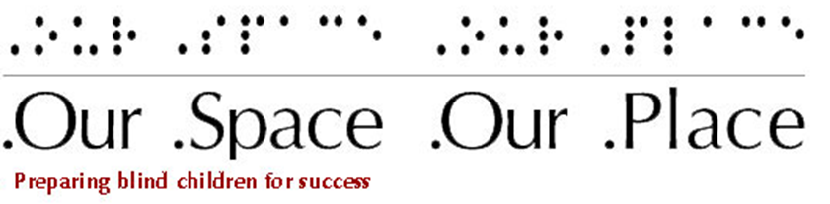

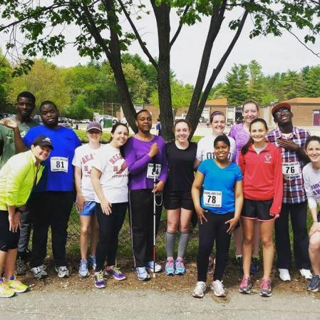
Fall 2015 Newsletter
As we move into the 2015-2016 program year, we want to briefly share with you all the achievements your support made possible. Our Space Our Place, Inc. was created to allow youth who are blind to have a space in which they can grow, explore and gain the confidence and skills needed to pursue their dreams. Your support creates all of the opportunities for youth who are blind to gain experiences that permit them to more fully participate in the community. We appreciate you choosing to make a difference in the lives of youth who are blind and we invite you to visit us and meet the students.
“I like that the students get involved in the community and have so much fun!!” – OSOP Teacher

Theater & Dance
The end-of-year performance allowed the students to share with friends and family everything they learned throughout the year. Armed with confidence, the students went through their dance routines, even though a conflict prevented our dance instructor from joining us. Thanks to the donations of the families, there was a great selection of beverages and foods for us to eat. We all had a joyous and fun time as all attendees participated in the theater segment of the day. Making a large circle we all had a chance to practice speaking clearly and loudly as we spoke up when it was our turn to recite the tongue twisters and used our listening skills as we listened intently to ensure that we could repeat the quite complicated hand claps. Participants agreed, “It was a blast!”
"Dance... where ‘I can't’ does not exist but ‘I will try’ does." – OSOP Teacher

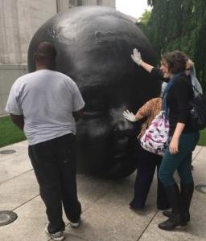
Experiencing Fine Arts & Science
Throughout the year, OSOP students visited the Museum of Fine Arts and the Museum of Science. The Computer Clubhouse at the Museum of Science was a popular site, as it allowed the students to record themselves singing in its recording studio. Tours of the Museum of Fine Arts ended with an exploration of the outdoor sculptures.
Adventures at the MFA have already started this program year. We toured pieces depicting the portrayal of deities in different religions, tried on a kimono and wrote haiku.
“Our space is great. We have many epic times just hanging out and working.”
– OSOP Student

Running & Racing
OSOP continued to participate in athletic events to keep the students fit and active. During the 2014-2015 program year, the students ran in the Reading 5K on May 16th and the Boston Athletic Association 5K race on April 18th. All of the students finished all of the races in which they participated. Through our partnership with MAB, sighted guides were available and ran with the students in preparation and the day of the races.
This program year, the students will run in at least two races. Thanks to the generous donation of Marathon Sports, all of the students received new running shoes. The students will also plan their first walk for Spring 2016.
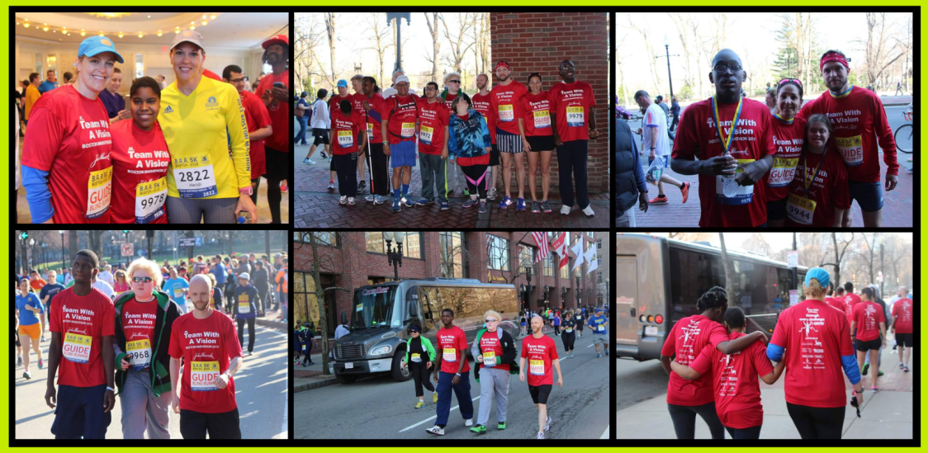
“Working with the kids from OSOP gives me immense satisfaction. To watch them practice and succeed helps to show them that anything is possible if you work hard and practice.” – OSOP Teacher

World of Careers
Fifty students with disabilities had the opportunity to directly hear from eleven professionals about their paths towards employment. For the first time, this year all of the professionals were individuals who are legally blind. The students learned about possible career options and of the personal choices and actions taken by the professionals to pursue their careers. At one table, a student discovered that a professional who now worked in a library once did the internship the student was beginning.
The Museum of Science continued its partnership with OSOP and donated the meeting space. Commissioner Paul Saner of the Massachusetts Commission for the Blind reminded us of the resources available through the state. Our guest speakers further enhanced our career exploration experience. Ellen Carr, a personal shopper, talked with us about the importance of our appearances when interviewing and some cost-effective options. Colleen Moynihan, a business developer from the New England Business Associates, reminded us that self-employment is also an employment option and shared resources which can assist someone who wants to create her own business.
World of Careers continues to be an important resource to introduce middle and high school students who are blind to possible career options.
The 2016 World of Careers workshop will be on February 25 at the Museum of Science.
“The [OSOP] program is amazing and cool and great.” – OSOP Student

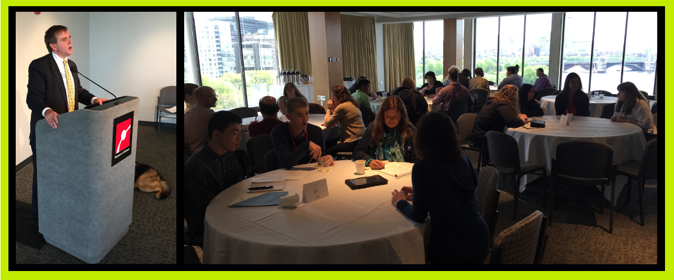

Fun in the Kitchen
In May, OSOP students and staff were treated to a special event, a Taco Party at the Create a Cook Kitchen. Two wonderful and adventurous ladies sponsored the event. They agreed to be blind-folded while they joined us in the kitchen. That day we made chocolate cinnamon cupcakes, fresh salsa and tacos with all of the fixings. All of the students including our special guests, chopped vegetables, used the food processors, browned the meat at the stove and filled the cupcake papers with batter.
For our students, the kitchens at Create a Cook are a space in which they are confident and comfortable. Year after year, the students practice their culinary techniques and learn new ways to prepare their favorite food.
“I enjoy meeting new people. It is a place that we can be ourselves.” – OSOP Student
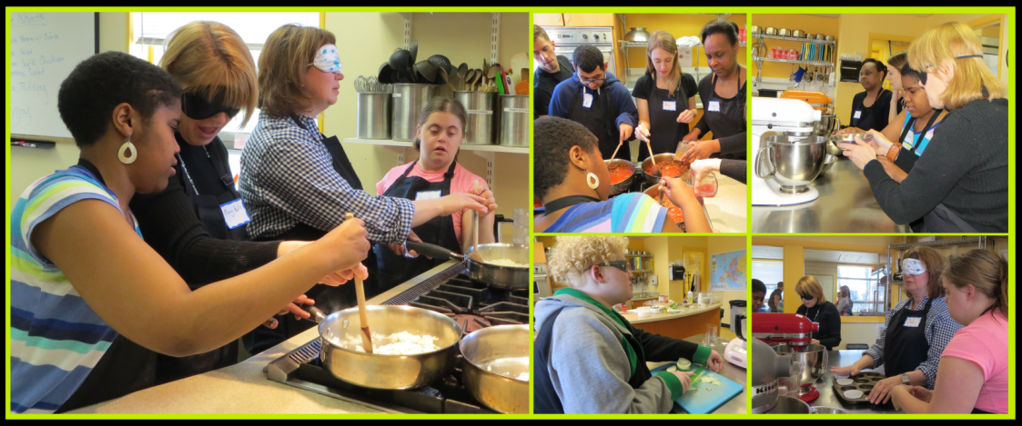

Organizational Growth
Thanks to your support Our Space Our Place, Inc. allowed seven youth who are blind to continue their personal growth and to explore career options. As we begin the 2015-2016 program year, we are poised to expand the program to more students; as the organization has become a preferred provider with the Massachusetts Commission for the Blind. This designation was gained because of the programming we have provided throughout the years and an intent to expand the career exploration component of the organization. Our goals are to double the number of students in the program, expand the career exploration program to include resume writing and mock interviewing, assist students to find work experiences and to develop two workshops in the STEM fields.

Volunteers
Thanks to our volunteers our students have an opportunity to meet and to interact with students their own ages. Every week students from Community academy for science and Health (CASH) in Dorchester join our group. They bring energy and spark that motivates the OSOP students to actively participate and to strive. CASH students ran as sighted guides in the two races with the OSOP students. Already this program year, they are engaging with the OSOP students in a discussion of bullying.
OSOP has volunteers who aid with the capacity building of the organization. A volunteer set up our Facebook page (https://www.facebook.com/ourspaceourplace) and aided with fundraising. For the last year, a volunteer has guided the Executive Director and a Steering Committee through the process of developing a business plan, identifying our current and future participants and examining the structural growth of the organization. Thanks to volunteers, Our Space Our Place, Inc. is well-positioned to facilitate the growth of youth who are blind.

Join the Board or Volunteer
Our Board of Directors is small and productive. The Board meets once every other month. The Board guides the organization, oversees its administration, identifies funding opportunities, and increases awareness of the work of the organization in the community.
For more specific information about being a Board member, please contact Cheryl Cumings Founder/Executive Director at president@ourspaceourplace.org or call (617) 459-4084.
Our Space our Place, Inc. is an organization that relies on volunteers. The work of volunteers contributes to the quality of the programs we are able to offer.
If you would like to join our Volunteers, visit our website (www.ourspaceourplace.org), and click the Volunteer button.
If you know someone who would be interested in receiving this newsletter or if you are interested in visiting Our Space our Place, Inc., please contact us.
Cheryl Cumings, Executive Director
president@ourspaceourplace.org | 617.459.4084 | www.ourspaceourplace.org

