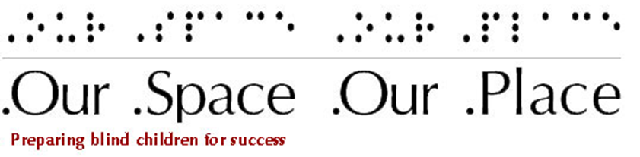

2016 Newsletter
Our Space Our Place, Inc. is a small organization that for many years has taken steps towards improving the lives of youth who are blind. Volunteers and donors play a significant role in these steps., Because of the work of volunteers, in addition to our regular programs for development and career exploration this year, we were able to expand our offerings and introduce workshops focusing on Science, Technology, Engineering, and Mathematics (STEM.).
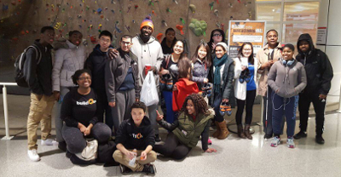
“How lovely to think that no one need wait a moment:
we can start now, start slowly changing the world!
How lovely that everyone, great and small,
can make a contribution toward introducing justice straight away.”
- Anne Frank

Developing Knowledge: Day of Science

The commitment and work of the members of the planning group made the first Day of Science possible. Amanda, Ashley, and Robyn shaped the content and identified partners who assisted with a location and food.
Ashley used her project management skills to communicate the actions and a timeline needed to achieve the Day of Science goals. Amanda applied her knowledge of science to develop three, fully accessible, hands-on experiments. Robyn used her contacts in the community to find a location for the program and snacks for the day. The New England Aquarium graciously agreed to provide the location for the program. The Haley House donated the snacks.
The result was that fourteen students from Boston, New Hampshire, and the Springfield area explored science in the areas of taste, sound and touch. The day ended with a panel of scientists who are blind sharing their experiences studying and working in different fields of science.
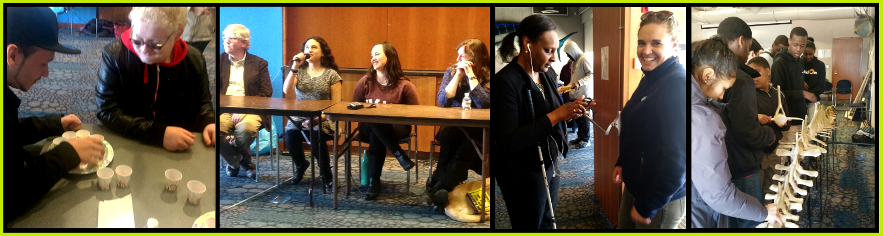

Growing Our Skillset: Coding Camp
Technology will continue to be a significant part of life. Therefore, the question arises: What action can be done to ensure that people who are blind are involved, not just as users, but as creators of technology?
Smarter in the City (a Roxbury, MA business incubator) provided space and connections needed to think through this question. Lynnette, Richard, Fernando, Abel, Rob, Gilad, and Tim volunteered to further investigate this question.
With their assistance, it became clear that one way to better position youth who are blind to contribute to the development of future technology is to introduce them to coding. Thanks to the work of the volunteers, a curriculum was developed. The volunteers assisted with tutoring students during the workshop.
During our week-long coding workshop the students worked to create their own websites. The instructors said the code out loud. The students wrote it down, saved, and tested it. Five students participated in this innovative workshop. One Connecticut student even participated via Skype!
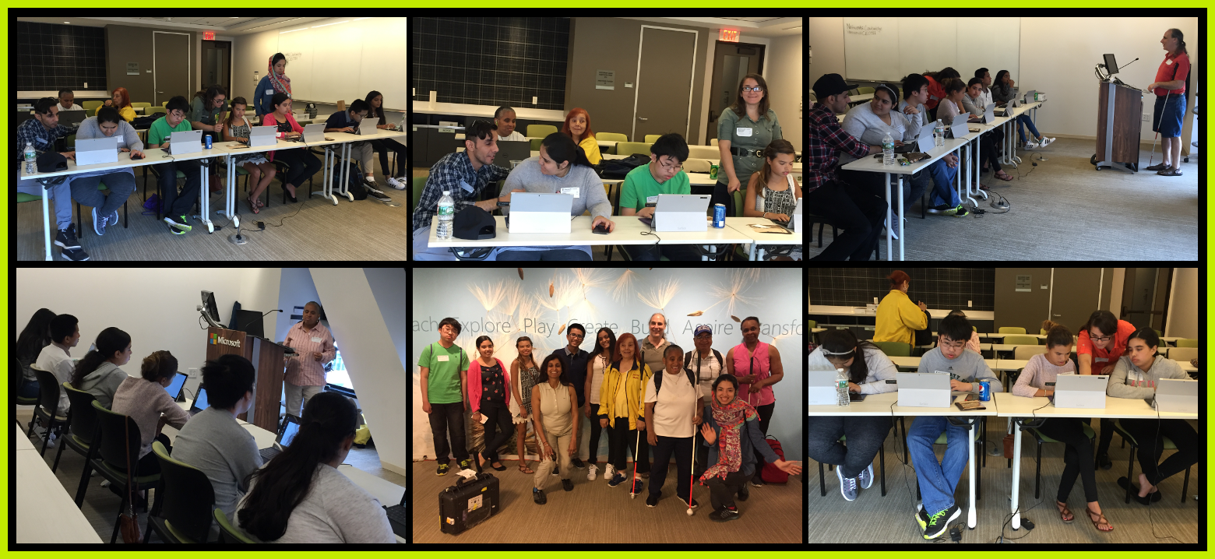

Exploring Japanese Cuisine: End of Year Dinner
The year ended with a dinner at one of Boston’s best sushi restaurants on Newbury Street. The restaurant owner donated the dinner to OSOP. The meal began with salted edamame. The restaurant manager described edamame and explained that in Japan edamame is eaten at baseball games instead of hotdogs. The manager then described the type of sushi and the way to eat it with soy sauce, ginger, and wasabi. We got lessons on how to use chopsticks.
Everyone had A great time!
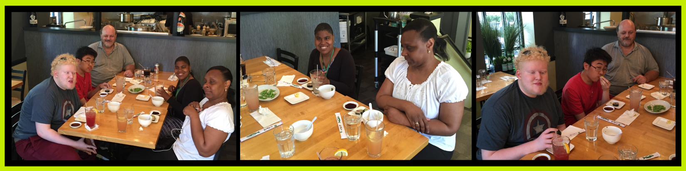

Touring the Museum of Fine Arts
At the Museum of Fine Arts, students explored the early and later paintings of French Impressionist Oscar-Claude Monet. They discussed how his work changed as his eyesight changed. Students toured the contemporary Mega Cities Asia; in which artists use sound, space, and garbage to comment on life in the current large cities in Asia.
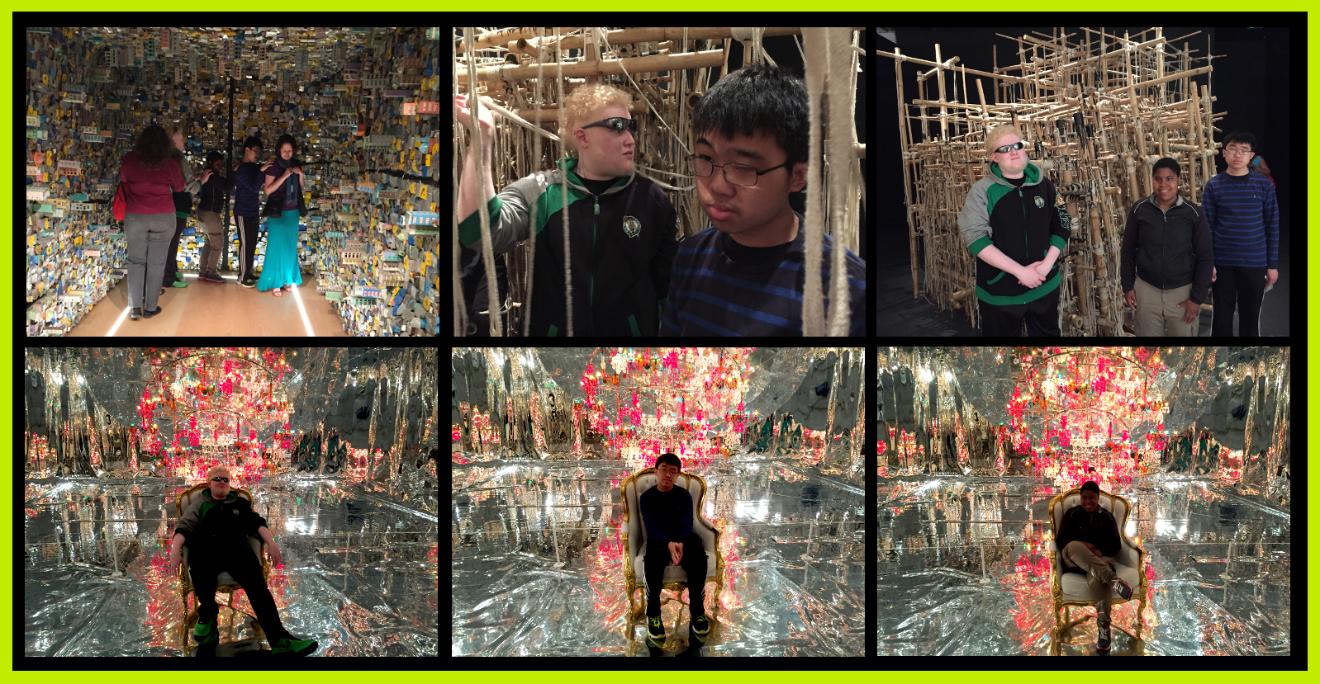

Preparing for the Workforce: World of Careers
Working with the Museum of Science, the annual World of Careers program was held. A mix of high school and young adults seeking employment participated in the discussions.
Two human resources representatives from the Museum of Science shared their knowledge about job hunting and a Massachusetts Commission for the Blind professional talked about soft skills with the participants.
The following audio clips provide great career resources:
- Job Searching Tips: http://www.ourspaceourplace.org/audio/job-searching-tips.mp3
- Soft Skills: http://www.ourspaceourplace.org/audio/soft-skills.mp3
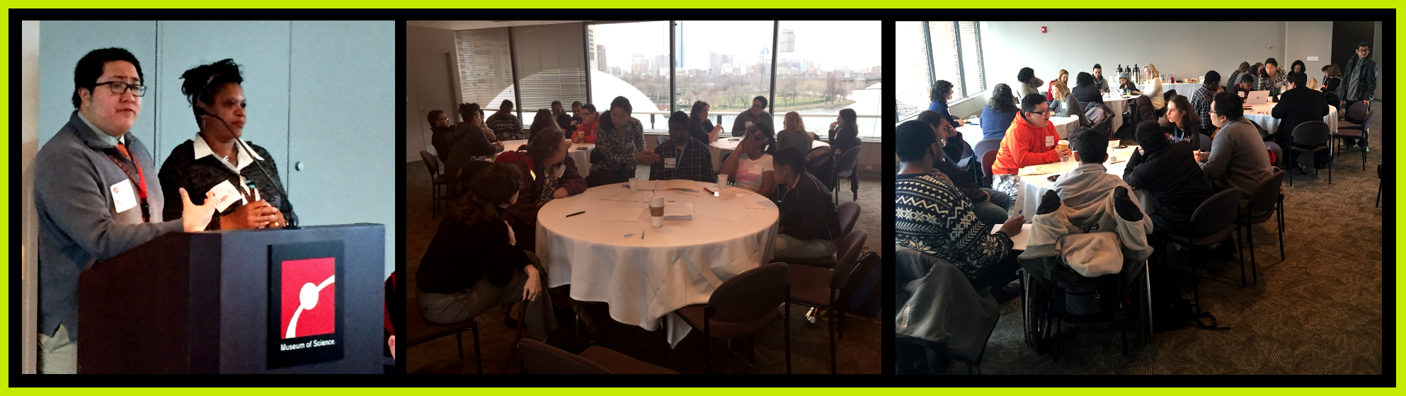

Fun in the Kitchen with Create a Cook
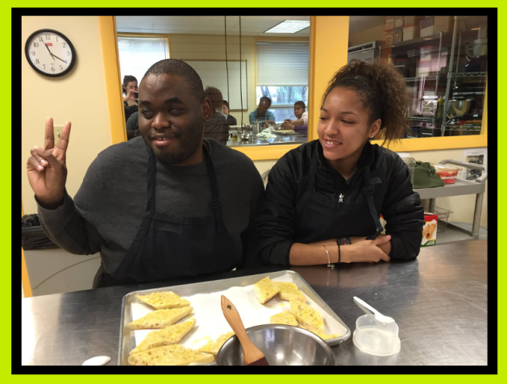
Create a Cook continues to partner with OSOP. Students have become more and more comfortable and confident using ingredients and kitchen tools to prepare meals. This year the students made extraordinary salads and delicious Italian meals.
The menu included the following dishes:
- Tomato, Basil and Cheese Baked Pasta with Fresh Basil Pesto
- Old School Garlic Bread
- Cannoli
The students also made over a hundred caramel and salted brownies, which were sold in the First Annual Bake Sale.

Entertaining Performances: Theater & Dance
Theater and dance continued as part of our core program.
At the end of year performance, each student performed a routine emcompassing both dance and theater techniques.

Each student selected a song that said something about themselves. One student selected Taylor Swift’s “Shake it Off”, and another selected John Legend’s “All of Me”.
With great confidence, the students shared a story about themselves. One student talked about a walking club he started in his neighborhood. Another student talked about how the words “adventuresome” and “optimistic” are lived out in her life. Each student then danced or sang. The audience then joined in.
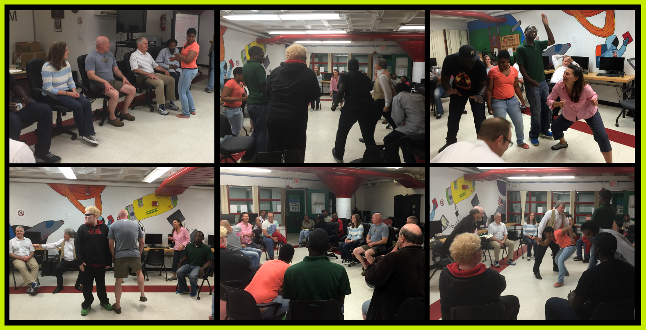

Keeping Fit: Boston Athletic Association 5 K
Throughout the program season, our students trained hard for the annual Boston Athletic Association 5K. After months of training, we’re proud to say we completed the race on April 16th! Thanks to the dedication of our volunteers and persistence of our students we’ve accomplished another year of staying fit and reaching this goal.
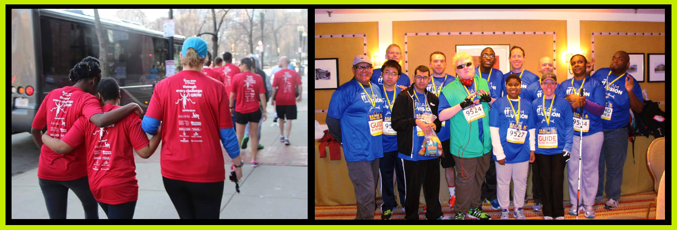

Fostering Community: Volunteering
Volunteering is so important to OSOP that this year we also volunteered with a local nonprofit. During the February school break, a few current and past students of OSOP spent time collating a braille book (Castles: How Are They Made) at the National Braille Press.
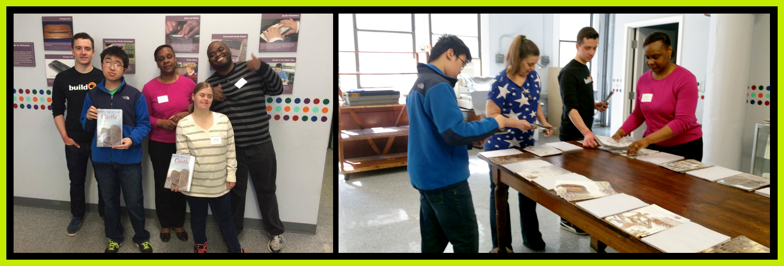
OSOP worked with our volunteers from the Community Academy of Science and Health (C.A.S.H.) on a service project. Together, we made blankets to donate to Boston Rescue Mission—an organization that works to assist the homeless.
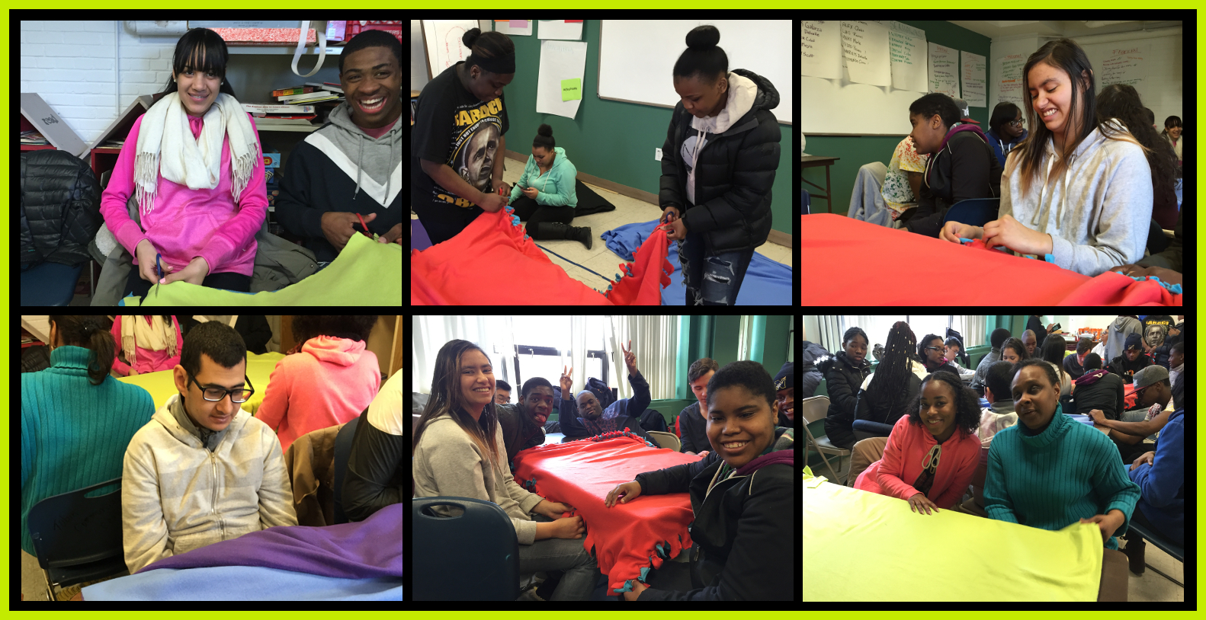
Volunteers at OSOP have assisted with financial and legal filings, grant applications, and outreach. Volunteers reached out to friends and donors to let them know about programming. Because of volunteers from C.A.S.H. and Boston Cares, every week we have a program where our students interact with youth their own age and meet adults from a wide swathe of the local community.
Our Space our Place, Inc. is an organization that relies on volunteers. If you would like to share your talents, skills, and knowledge with OSOP as a volunteer, contact Cheryl at: President@ourspaceourplace.org. You can also visit our website (www.ourspaceourplace.org), and click the Volunteer button.
Cheryl Cumings, Executive Director
president@ourspaceourplace.org | 617.459.4084 | www.ourspaceourplace.org

If you know someone who would be interested in receiving this newsletter or if you are interested in visiting Our Space our Place, Inc., please contact us.

